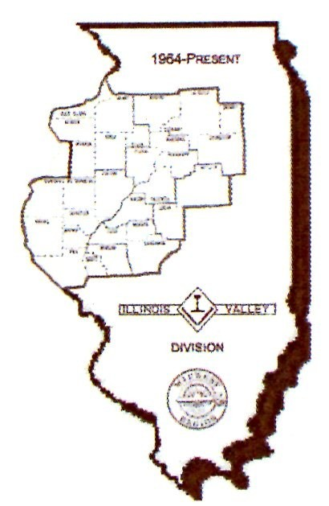
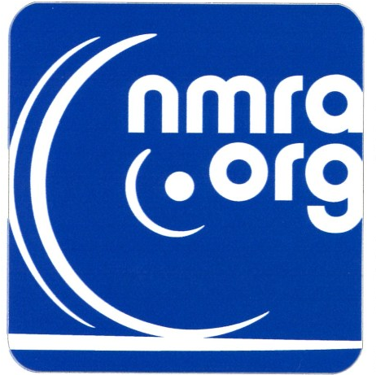
THE TIMETABLE
THE OFFICIAL NEWSLETTER OF THE

ILLINOIS VALLEY DIVISION
NATIONAL MODEL RAILROAD ASSOCIATION
Volume 44, No. 2, March 2025
WEBSITE: nmra-ivd.org

FROM THE SUPERINTENDENT
Notch 2
March of 2025 marks the end of my first year as Superintendent of the IVD and even though there have been many hiccups and frustrations along the way as I struggled to get my arms around all the intricacies and nuances of the job, I think I can finally say I’ve have made it to notch 2 with a fairly clear stretch of rail ahead that will allow me to better focus my time on our primary mission of not only increasing membership, but just as importantly, how to get existing members to more actively participate in IVD activities.
Along these lines, NMRA Magazine editor
Cinthia Priest wrote a very interesting article in the February magazine about the difference between being interested in something and being invested in it. To quote Cinthia, “an interested person is one who won’t take risks, shifts their focus, and gives up easily to the point of quitting. Conversely, the invested person takes risks, spends time, digs in, and keeps going no matter what”. For another point of view I thought it might be interesting to go to Google and see what artificial intelligence had to say about it and it came up with this: While both "invested" and "interested" can suggest a level of curiosity or concern in something, "invested" implies a deeper commitment and active participation, often involving dedicating time, energy, or resources, whereas "interested" simply means having a casual curiosity or desire to know more about something. In my view, both Cinthia and Google’s AI Bot hit the nail on the head. There are a lot of people interested in various things but for one reason or another they can’t or won’t take the extra step to make a deeper commitment to it.
The IVD is no different in this regard and you only have to take a look at the attendance sheets for our meets over the years to see that there are 10 or 15 “invested” members who attend the meets regularly and actively contribute to IVD activities. The other 70 or so would seem to only be “interested”. How do we motivate them to make the leap from “interested” to “invested”? It’s a good question with no easy answer but it has to come from the top so I challenge the Trainmasters to talk to the people in their districts and get their ideas about what would make them more active participants and see what we can do to accommodate them.
One thing we’ve talked about among ourselves is more make and take clinics to get people involved and Larry Nelson is going to kick it off with a clinic on sign making at the upcoming March 15th meet, so be sure to attend and go home with a new sign for your layout! Something that I’m personally doing is to reach out to external speakers, model RR manufacturers, and members from other regions to consider giving clinics at our meets or possibly provide materials for make and take projects. Super clinics on topics of special interest is another good idea that has had some success in the past. And recently there has been a push to hold operating sessions on members’ layouts to not only have fun and socialize, but to provide a way for members to log time toward the dispatcher AP while they’re running the trains.
What ideas do YOU have ? Make the leap and become invested in the IVD !! ….
Gary Baker – Superintendent

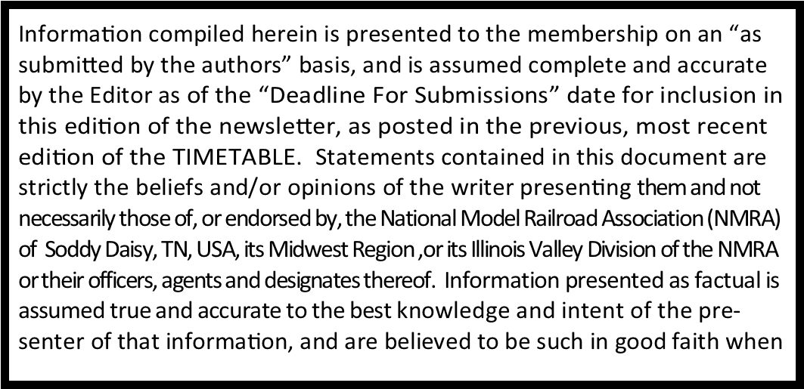
Upcoming 2025 IVD Meetings Membership Meetings:
Meetings are held on the third Saturday of January, March, May, September and November at a branch of the Peoria Public Library, Peoria. Doors open at 12 noon for a time of fellowship. A $3.00 donation is welcomed by members which qualifies each donor participation in the door prize drawing.
MARCH MEEETING
Peoria Public Library, North Branch
West Grand Parkway, Peoria
The March 15, 2025 meeting of the Illinois Valley Division will be held in the conference room of the library, located to the right just inside the main doors. See the map on page 12. The program and clinic will be a “make and take” on constructing billboards by Larry Nelson.
Gary Baker will have his layout open following the meeting.
The popular vote contests for March 2025 are:. (1) Diesel Locomotives and (2) Photos of Models
Board of Directors Meetings:
The next Board of Directors Meeting will be Monday, April 21, 2025, 6:30 pm by Zoom. Members who wish to attend need to contact Gary Baker, Superintendent, at the email address listed to the left of this page to receive the Zoom invitation.
2025-6 Popular Vote Contests
March:
Diesel Locomotives Photos of Models
May:
Buildings Off-Line
MOW Cars, Vehicles and Equipment
September:
Photos from a Layout
Specialty Railroad Cars, Non-MOW
November:
Passenger Cars Bridges
January (2026)
Scenery, any season
Photos of protype railroading
March (2026)
Scratchbuilt, any category Kitbash, any category

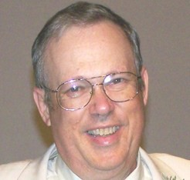
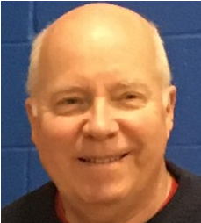
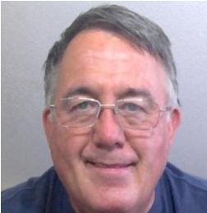
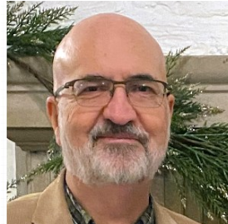
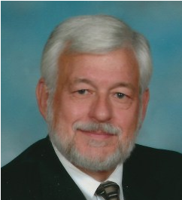
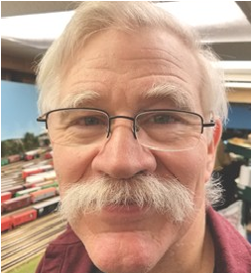
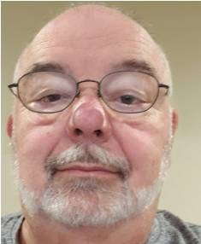
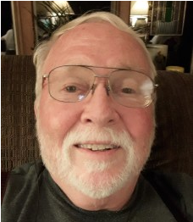
DIVISION OFFICERS
To Be

Appointed

SUPERINTENDENT (2026)
Gary Baker
309-264-6797 afpgary@mac.com
ASST. SUPERINTENDENT (2025)
IVD TIMETABLE EDITOR and AP HAIRPERSON Minton Dings, MMR®
(309)-241-4504 greenriverbranch1957@gmail.com

CHIEF CLERK (2026)
Randy Sommer
(309)274-4563
chief.clerk@nmra-ivd.org

PAYMASTER (2025)
Jeff Deasy
217-836-0223 paymaster@nmra-ivd.org

TRAINMASTERS
District 1—Peoria & Tazwell Counties (2025)
Russ Smith
309-255-2058
district1@nmra-ivd.org

DISTRICT 2 - Grundy, Livingston, McLean &
Woodford Counties
To Be Appointed

DISTRICT 3 - Bureau, LaSalle, Marshall, Putnam & Stark Co. (2025)
David Hawkey
(309)274-6150
district3@nmra-ivd.org
DISTRICT 4 - Fulton, Henry, Knox, Rock Island and Warren Co. (2026)
Larry Nelson
(309)789-6447 district4@nmra-ivd.org
DISTRICT 5 - Adams, Brown, Cass, Logan, Mason, McDonough, Menard, Morgan, Pike, Sangamon, Schuyler & Scott Co. (2025)
Thomas Ose
(217)483-4368
district5@nmra.ivd.org
The year listed with title indicates the end of the present term.
2023 Illinois Valley Division, Midwest Region, NMRA
All rights reserved but permission will usually be granted by the contributors and editor
Contact editor at greenriverbranch1957@gmail.com

OFFICES TO BE ELECTED AND MEMBERS OFFERING TO SERVE FOR THE 2025—20266 TERM

ASSISTANT SUPERINTENDENT: Term of two
years. For Election by all Members of the Illinois
Valley Division
MINTON DINGS
I have been a model railroader for over 60 years. I have been a member of the NMRA from 1982 to 1994 and again since 2004. I was previously the assistant superintendent from 2011 to 2019, then appointed to the position by the Board of Directors from 2020 to 2021 and elected again for 2021 to 2023.
I am a retired paramedic and firefighter and previously a pastor. Retirement has afforded me the time to become more involved in the NMRA, the Illinois Valley Division and model railroading projects. I model the Illinois Central Railroad in West Central Kentucky in 1957, the transition era from steam to those colorful GP7 and GP9 diesels.
Currently, I am also the editor of our newsletter, THE TIMETABLE. My goals are to see growth in our division; reaching young model railroaders, those who are recently retired and have fond memories of their trains of their youth, encouraging families to make model railroading a family affair and members sharing their knowledge and skills.
I would be honored to continue to again serve as the Assistant Superintendent and to work to see the fulfillment of the goals I have stated above.
PAYMASTER: Term of two years. For Election by all Members of the Illinois Valley Division
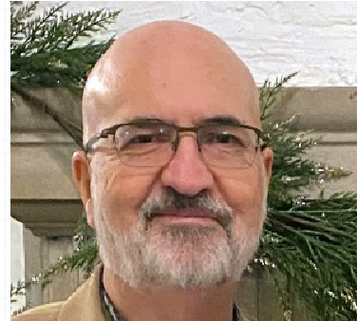
JEFF DEASY
I am a transplant to Illinois and was raised in Franklin, Kentucky, a small town south of Bowling Green. I met the love of my life, we married and had two children. (almost 45 years ago!) During this season of my life, I became interested in HO train layouts, of course back then it was DC. I had a 4X8 layout that I worked on for years and of course changed and changed again.
I joined NMRA and the Illinois Valley Division in 2016 and have been a member since. I started out as a member, then the Superintendent asked me if I would consider being the Trainmaster over District 2, I was appointed to that position, then later he asked me if I would consider being the Paymaster instead and he appointed me for that position. I gave up Trainmaster and became the Paymaster and have been doing that for the last couple of years. I have enjoyed being the Paymaster and am willing to continue this role if the Division would like me to.
TRAINMASTER: District 1, To be elected by members residing in Peoria and Tazwell Counties.
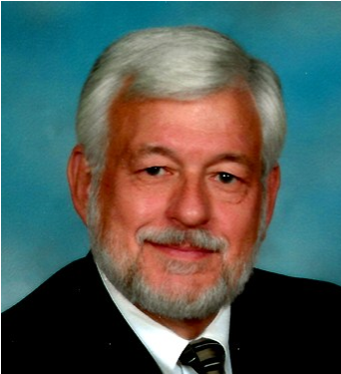
RUSSELL SMITH
I am a retired United Methodist clergy. I have been modeling off and on since 1977. I model the GM&O /Alton Route which ran through my home in Cass County on the Jack Line. My layout is about 22
x 26 feet, double tracked, DCC controls with three yards of varying sizes. I am standing for election for the District 1 of the Illinois Valley Division, NMRA.
TRAINMASTER: District 3. To be elected by members of Bureau, LaSalle, Marshall, Putnam and Stark Counties.
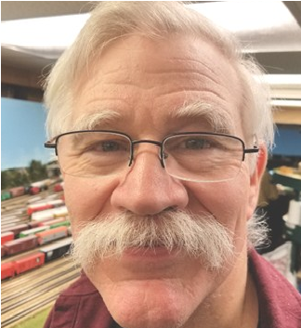
DAVID HAWKEY
I have enjoyed model railroading since childhood, and have benefitted immensely from encouragement, support, information, inspiration, and instruction provided by modelers in local and national model railroad groups. I have tried to follow their example by actively encouraging and supporting others’ modeling efforts; promoting the hobby through attending and hosting layout open houses and operating sessions; offering ideas and hands-on assistance in the design, construction, and operation of others’ layouts; presenting clinics at the division level; and writing an article in the Steel Mill Modelers Journal.
I’ve been a member of the NMRA since 2005, served as Chief Clerk from 2005 to 2008, and currently am the Trainmaster for District 3. When we were planning to host the NMRA Midwest Regional Convention in 2020, I coordinated scheduling hosts and registering visitors and operators for the Layout Tours and Operating Sessions until COVID forced cancellation of the Convention. I‘ve hosted the weeks-long refurbishing of the IVD modules at my home, twice, and I support continuing to offer hands-on model railroading experiences to children and adults by assisting our Division in displaying the modules at train meets and other events in Central Illinois. (Continued on page 4)
TRAINMASTER: To be elected by members from Adams, Brown, Cass, Logan, Mason, McDonough, Menard, Morgan, Pike, Sangamon, Schuyler and Scott Counties.
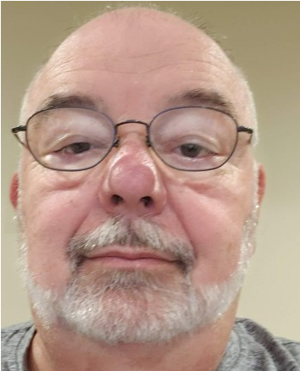
THOMAS OSE

I rejoined the NMRA in
2016 after being away from the hob by. Since that time, I have been active as the secretary of the Gateway Division and Trainmaster of District 5 of the Illinois Valley Division. I
have presented numerous Sessions
on how electronics are available for
the hobby and four sessions on how to program and use the Arduino controller. I have organized two monthly meetings at the Chatham depot. My hobby interests are primarily centered around Mid-German railroading during the transition period. I model HO scale and use Marklin trains and rolling stock. I concentrate on providing great detail on my layout and use electronic controls for both lighting and automation. My scenery and buildings are mostly kitbatched or scratchbuilt.
When I am not working on my layout I repair and upgrade customers' engines and build custom models. When I am totally bored, I will use my 3d printers to create characters that are then painted with great detail.

SUGGESTED REFEERENCE by Minton Dings, MMR®
I an admirer of
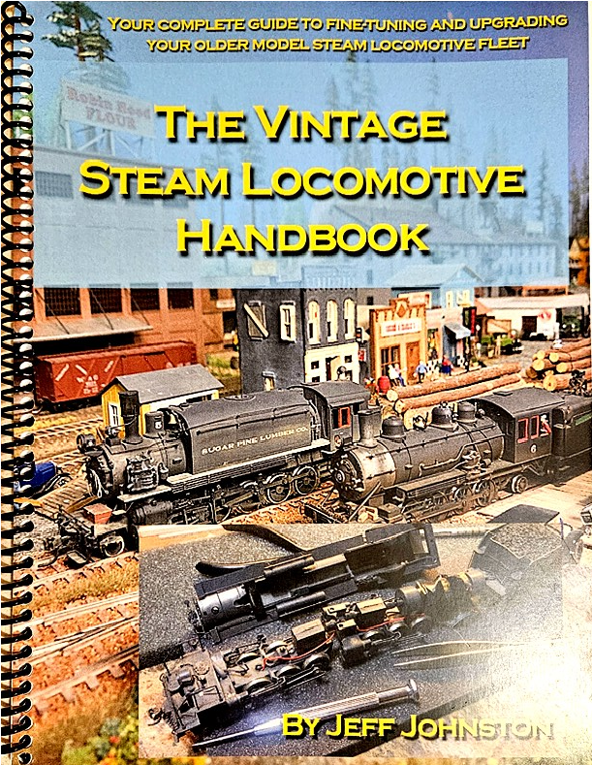
and collector of steam locomotives. Wherein there are many books on upgrading and maintaining diesel locomotives There is very little information on stream loco-motives. I have been searching for a good book as a reference for upgrading and maintenance of
model steam loco-motives. I have gone so far as inquiring of Tony Koester, at the time when he was modeling the Allegany Midland, a mostly steam railroad, if he knew of or would write a steam locomotive maintenance book. His answer was that he wished someone would do just that.
In the September-October issue of the Narrow
Guage and Short Line Gazette, editor Robert (Bob) Brown, MMR®, reviewed The Vintage Steam Locomotive Handbook, by Jeff Johnston, published in 2024. From Bob’s recommendation, I ordered a copy. The author has been writing articles on upgrading steam locomotives and improving performance for over thirty-five years. His contributions have appeared in Model Railroader, Railroad Model Craftsman, Model Railroad Hobbyist, Timber Times, Sn3 Modeler among others. He and his wife, Pam, both skilled craftsman level modelers, model the Sugar Pine Lumber Company/Minarets & Western Railway in September of 1927.'
There are many, many steam locomotives in brass from the 1950s through the 1980 imported from Japan, Korea and China which are beautiful shelf displays but did not run very well. And are not DCC equipped. Many of these steamers are available in hobby shops and can be found at train fairs and estate sales. There are also the early attempts by manufactures in the US which were not well detailed and were poor runners. I have a closet full of them!
Chapter 1 is an introduction to the handbook. The following chapters include adding contact wipers to improve electrical pickup for smooth running, adding weight for better traction, driveline replacement, proper packaging for safe storage, and tools needed for upgrades and maintenance.
It should be evident that there cannot be a handbook which covers all the possible locomotives which should be and could be improved. That would be a library. The locomotives covered in the next 10 chapters of the handbook are the IHC 2-8-0, Buchmann 4-8-4, Bachmann 2-8-0, Rivarossi 2-8-8-2,
Athearn 2-8-2, Mantua 2-6-6-2, Model Die Casting 28-0, Pacific Fast Mail Heisler, North West Short Line 2-6-2T and North West Short Line Rayonier 2-8-2.
Although I bought the book with the thought of possibly recovering some of my stored DC locomotives, I discovered this handbook showed me how to improve even my more modern steam locomotives and definite hints as to maintaining them. There are ample illustrations to show each step of projects. The 108-page handbook is paperback with a heavy paper cover and a spiral binding. The spiral binding allows the handbook to be laid flat on the workbench during projects.
The Vintage Steam Locomotive Handbook is available from Pictures and Words Productions, 3405 Videra Drive, Eugene, Oregon, 97405. 541/914-1152 or spLco-mwry@comcast.net or thesugarpineshop.bigcartel.com.
Price is $34.00 plus tax and shipping.
ILLINOIS VALLEY DIVISION 2025 BOARD OF DIRECTORS BALLOT
PLEASE READ INSTRUCTIIONS ON HOW TO VOTE CORRECTLY BY DISTRICT.

- Record your name and NMRA Membership Number in the lower right corner of this instruction box.
- To Submit Your Ballot, fold the ballot address outward, tape shut on both ends and add a First-Class Stamp or send your ballot digitally as delivered to you by e-mail.
- Mail-In Ballots must be received no later than March 14, 2025, by mail or be delivered to the meeting on March
15, 2025 to be counted.  4. Ballots must be submitted by mail or digital format, delivered to all e-mail addresses of Illinois Valley Division members as provided to the NMRA. | NAME __________________________ AND  NMRA MEMBER #__________________
FOR THE OFFICE OF ASSISTANT SUPERINTENDENT
Vote for all Members of the Illinois Valley Division
Minton Dings

FOR THE OFFICE OF PAYMASTER
Vote for all Members of the Illinois Valley Division Jeff Deasy

*** IMPORTANT—VOTE FOR TRAINMASTERS IS VALID ONLY FOR IVD MEMBERS
RESIDING IN THE INDICATED COUNTIES. VOTES FROM MEMBERS WHO RESIDE OUTSIDE THE INDICATED COUNTIES WILL NOT BE COUNTED. FOR THE OFFICE OF TRAINMASTER OF DISTRICT 1
Vote Only For Members of the Illinois Valley Division residing in Peoria and Tazewell Counties.
Russell Smith

FOR THE OFFICE OF TRAINMASTSER OF DISTRICT 3
Vote only For Members of the Illinois Valley Division residing in Bureau, LaSalle, Marshall, Putnam and Stark
Counties
David Hawkey

FOR THE OFFICE OF TRAINMASTSER OF DISTRICT 5
Vote only For Members of the Illinois Valley Division residing in Adams, Brown, Cass, Logan, Mason, McDonough, Menard, Morgan, Pike, Sangamon, Schuyler and Scott Counties
Thomas Ose

NOTE: Only one candidate is listed per position because no other members indicated their willingness to run for an office.

__________________________________________________________________________________________________________

Randy Sommer, Chief Clerk

Illinois Valley Division, NMRA 56 Waupakee Court

Hopewell, Illinois 61561-9469

__________________________________________________________________________________________________________
_

JANUARY 2025 LAYHOUT TOUR
GREGOR MOE, HO
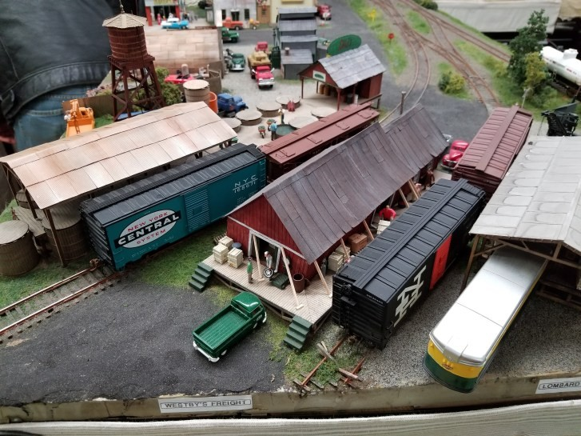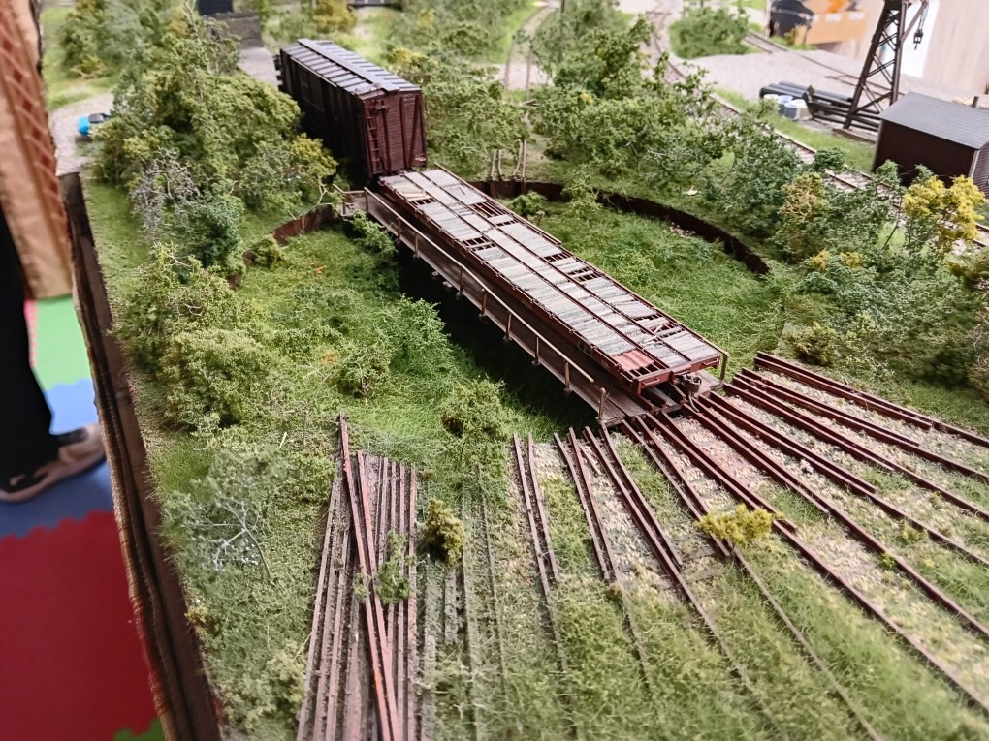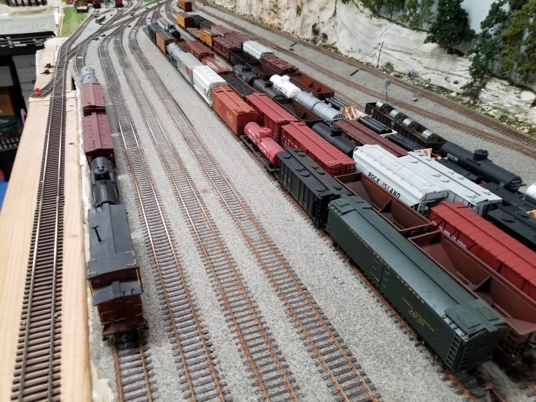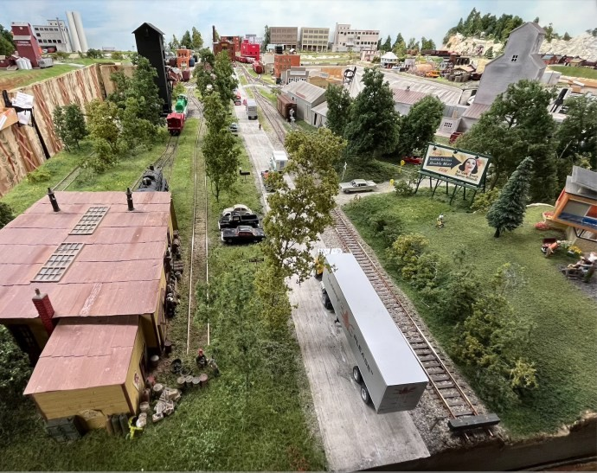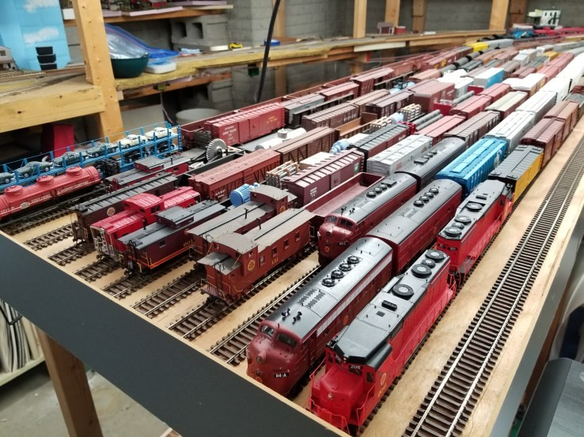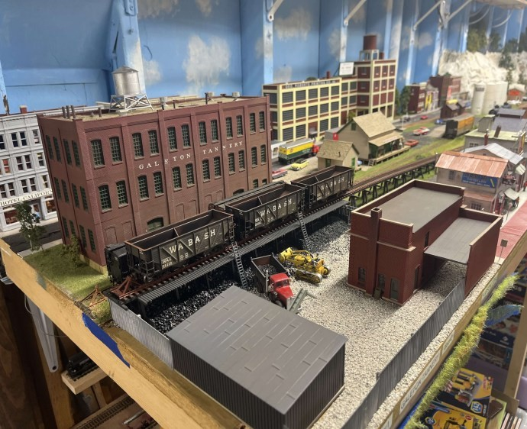

THOMAS OSE, HO
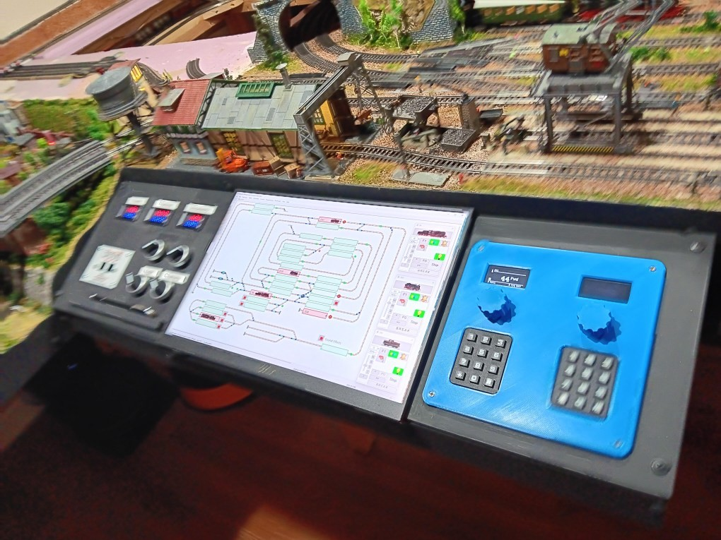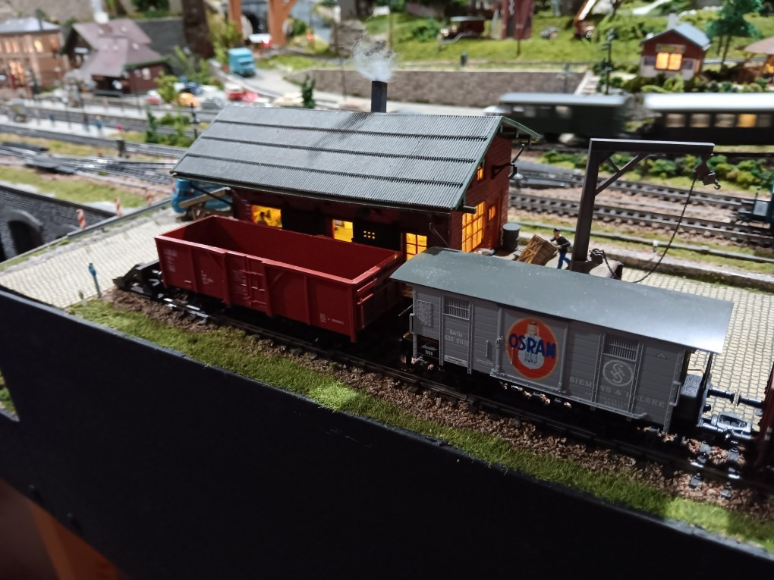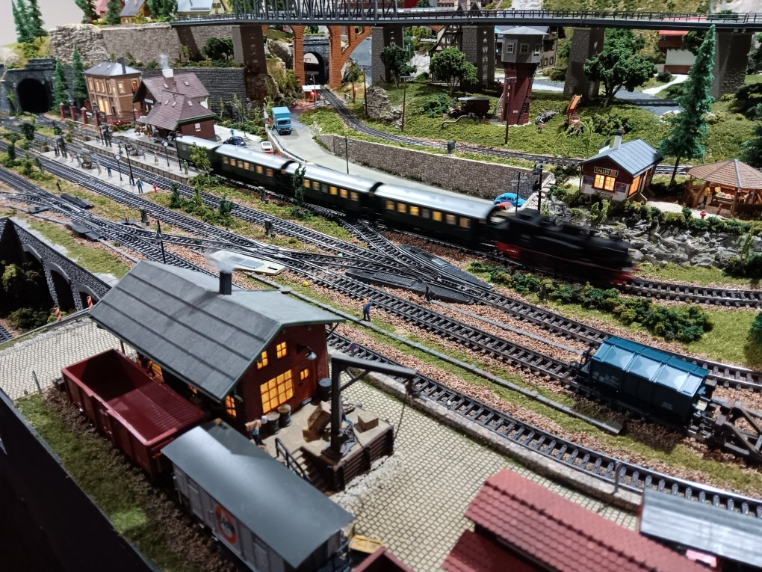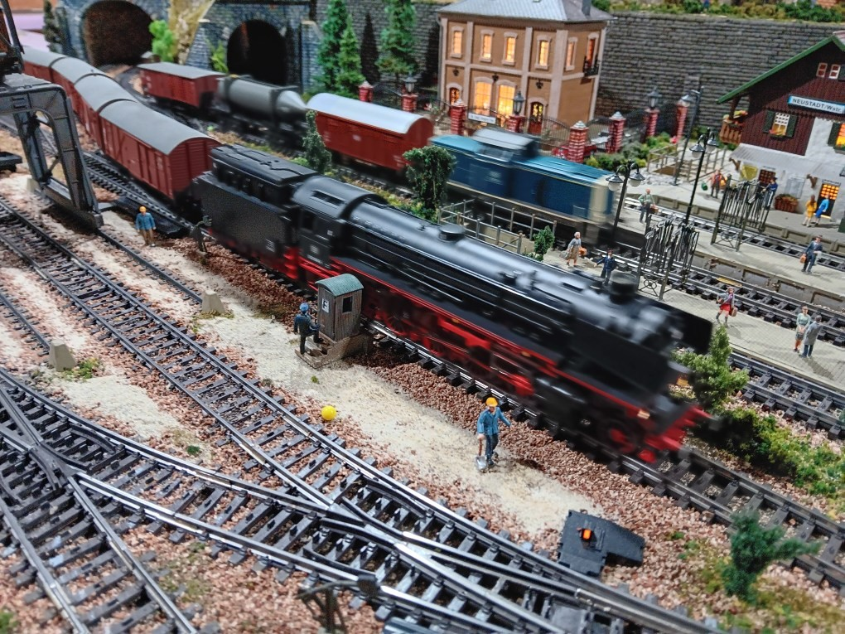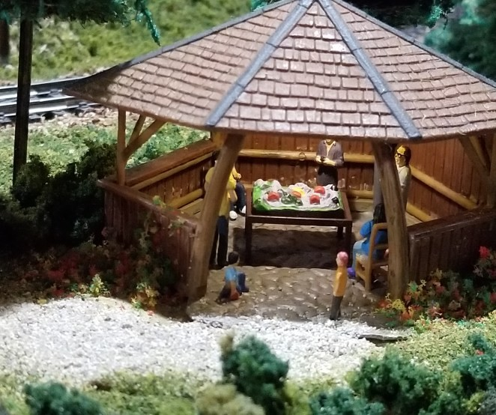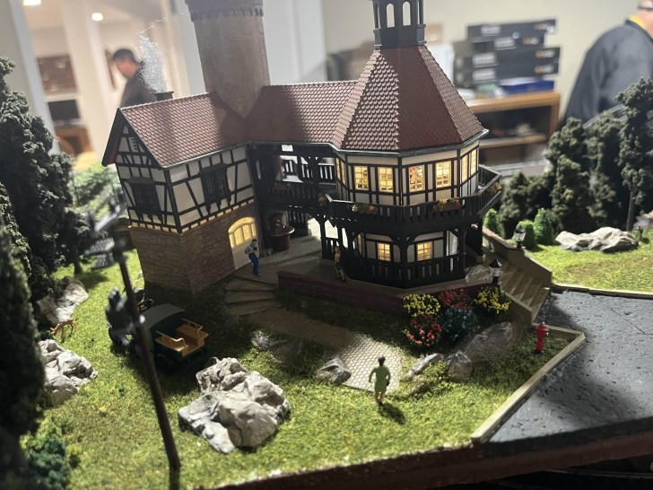
Layout in the layout
Thanks to Gary Baker and Jeremy Bubb for providing photos.

HINTS TO BETTER ODELING
by Roger Kujawa

A STEP UP
Sometimes you need to step up to the plate.
Sometimes you need a hand. I saw this at Kerry Delvecchio’s layout. He made some step stools and added some handles to steady yourself getting on and off. A great idea for anyone of my age. A fall could put you out of commission for quite a while. (Or also be disastrous if you fell onto the layout—editor).
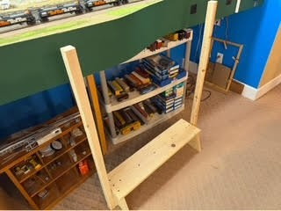

A GOO SCREW HOLDER
With miniature models comes miniature
screws. Sometimes you just can’t find a way to get a screw back into the hole. On an Athearn loco I was working on, the shell was held with screws under the trucks. Tweezers and my screw holder were bit too big to get the screw into to the hole. A small dab of Goo on the screwdriver was just en-ough to hold the screw so I could get it in the hole.
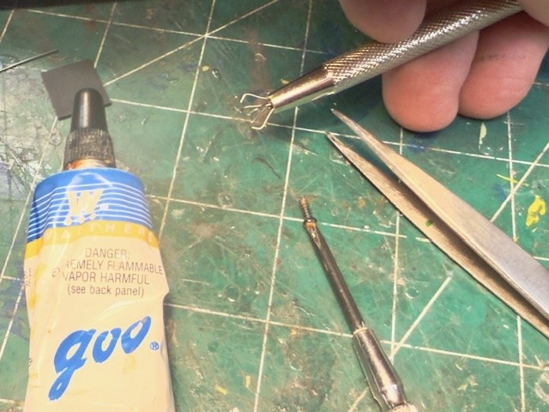
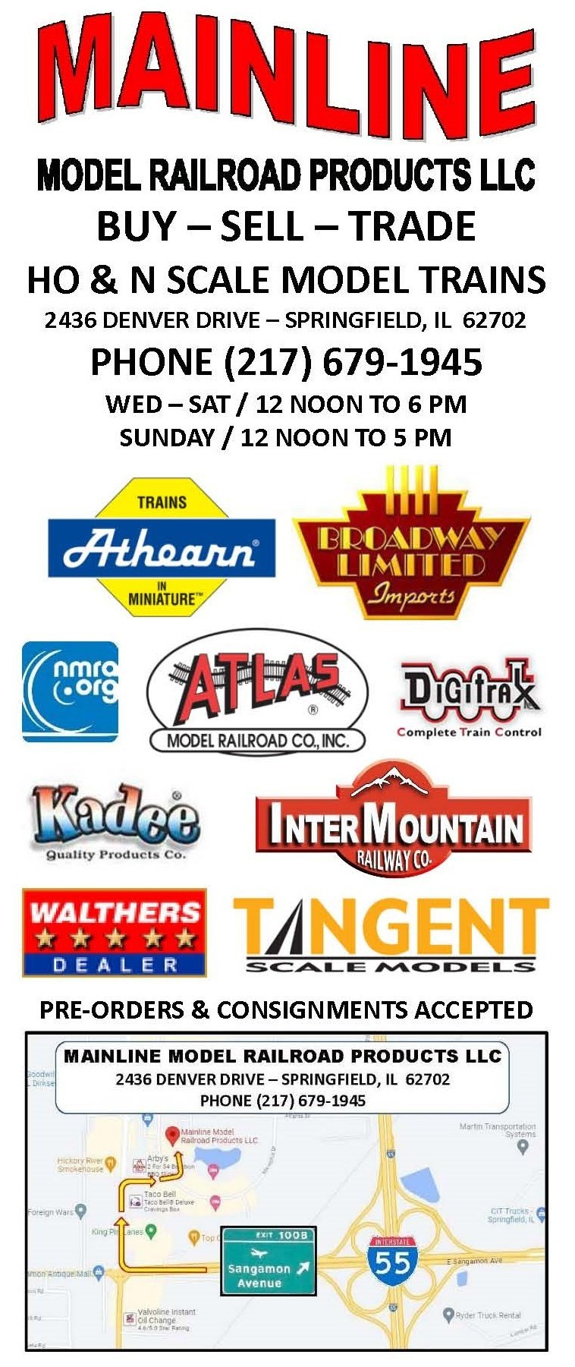
MAILED TIMETABLE
SUBSCRIPTONS DUE
Mail $10 to Minton Dings, 15548 SR 78,
Havana, Illinois 62644-6803

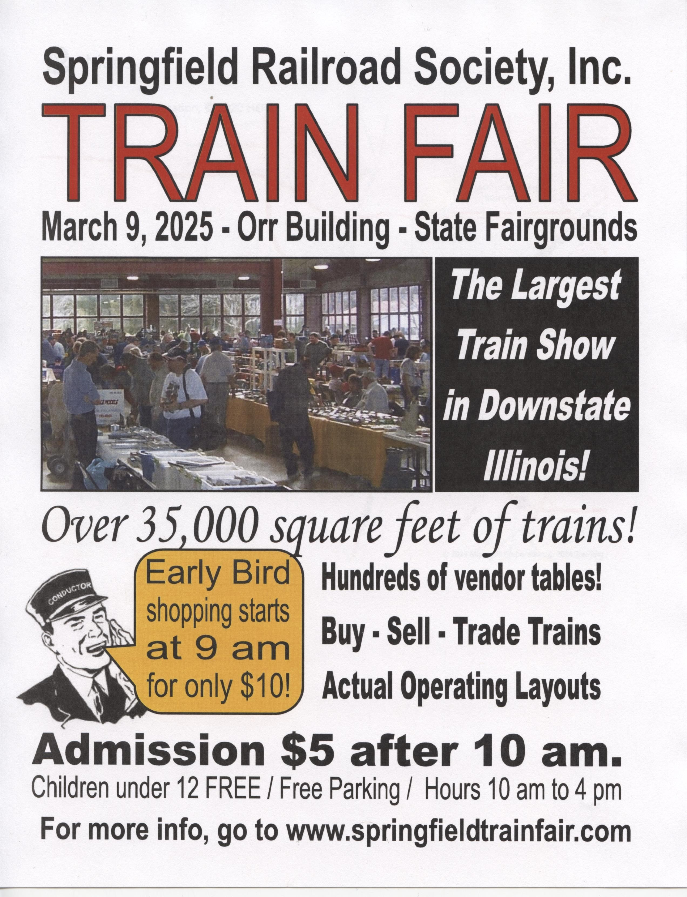

UPCOMING OPPORTUNITIES FOR MODEL RAILRODERS
PERSONAL AND BUSINESS
ADVERTISEMENTS AVAILABLE
Personal business-sized layout ads are available to Illinois Divisions members at no cost.
Business: One Year, 6 Issues
Website Timetable Both
Business Card Size: $20.00 $12.50 $30.00
Business Card X2: $30.00 $25.00 $45.00
Business Card X3 $40.00 $35.00 $60.00
Business Card X4 $50.00 $50.00 $75.00
Column or 1/2 Page $60.00 $60.00 $90.00
Make checks to Illinois Valley Division, NMRA. Send to
Minton Dings, 15548 State Route 78, Havana, IL 62644-6803. When recorded, checks will be forwarded to the paymaster.

Great Midwest Train Show, Sunday, April 5, 2025,
DuPage County Fair Grounds, 2015 Manchester Road, Wheaton, Illinois. The show is scheduled for the first Sunday of each month of 2025 (except no show in July), 9 am to 3 pm. Admission $7, online $6, and children under 11 free. Free parking and handicapped accessible.
Boeing Employees Railroad Club St. Louis Railroad Swap Meet, Saturday, March 8, 2025, 10:00 am to 3:00 pm, Greenfelder Recreation Complex at Queeny Park, 550 Wiedeman Road, Baldwin, MO. Admission not listed. Free parking and handicapped accessible.

Springfield Train Fair, Sunday March 9, 2025,
10:00 am to 4:00 pm, Orr Building, Illinois State Fairgrounds, Springfield, IL. Admission $5.000, children under 12 free. Early bird admission $10.00 for 9:00 am entry. Free parking and handicapped accessible.
Illinois Valley Division Meet, Saturday, March 15, 2025 1:00 pm to 4:00 pm. Doors open at 12:00 noon, Peoria Pubic Library, North Branch, 3001 West Grand Parkway, Peoria, IL. $3 donation accepted. Information is also available at the division’s website nmra-ivd.org. [Grab your reader’s attention with a great quote from the document or use this space to emphasize a key point. To place this text box anywhere on the page, just drag it.]
REMINDER
Advertisement & Subscribers Fees are Due Each January
Fees for subscribers of the mailed copies of the Timetable are due at $10.00 for five copies.
Commercial ad fees are also due
according to the size of the ad. The fee schedule for Timetable or website or both Timetable and website are found above.
Send checks to Minton Dings, 15548 SR 78, Havana, Illinois 62644-6803.
When recorded, the checks will be forwarded to the IVD paymaster.

Lincoln Square Train Show, March 29-30, 2025,
Lincoln Square Village Mall, 100 West High Street, Urbana, IL. Admission free. Sponsored by the Illinois Terminal Division, NMRA. Parking free, Handicapped accessible. No time listed.
Rail Fair, Saturday, July19, 2025, Copeland Park, Rose and Clinton Streets, La Crosse, WI. ock River Valley’s Annual Train Show and Sale, Saturday 10:00 am to 5:00 pm and Sunday, 10:00 am to 3:00 pm, March 29 and 30, 2025, Harlem High School, 9229 North Alpine, Machesney Park, IL. No admission listed. Free parking and handicapped accessible.

NMRA NATIONAL CO NVENTION, STATION
VI, July 14-19, Sheraton Hotel, Novi, Michigan. This is the 90th Year Celebration of the founding of the NMRA. The convention will be held in the hotel as will the National Train Show on Saturday and Sunday, July 19 and 20. More Information and registration is available at the convention website: nmra2025.com. More information later!
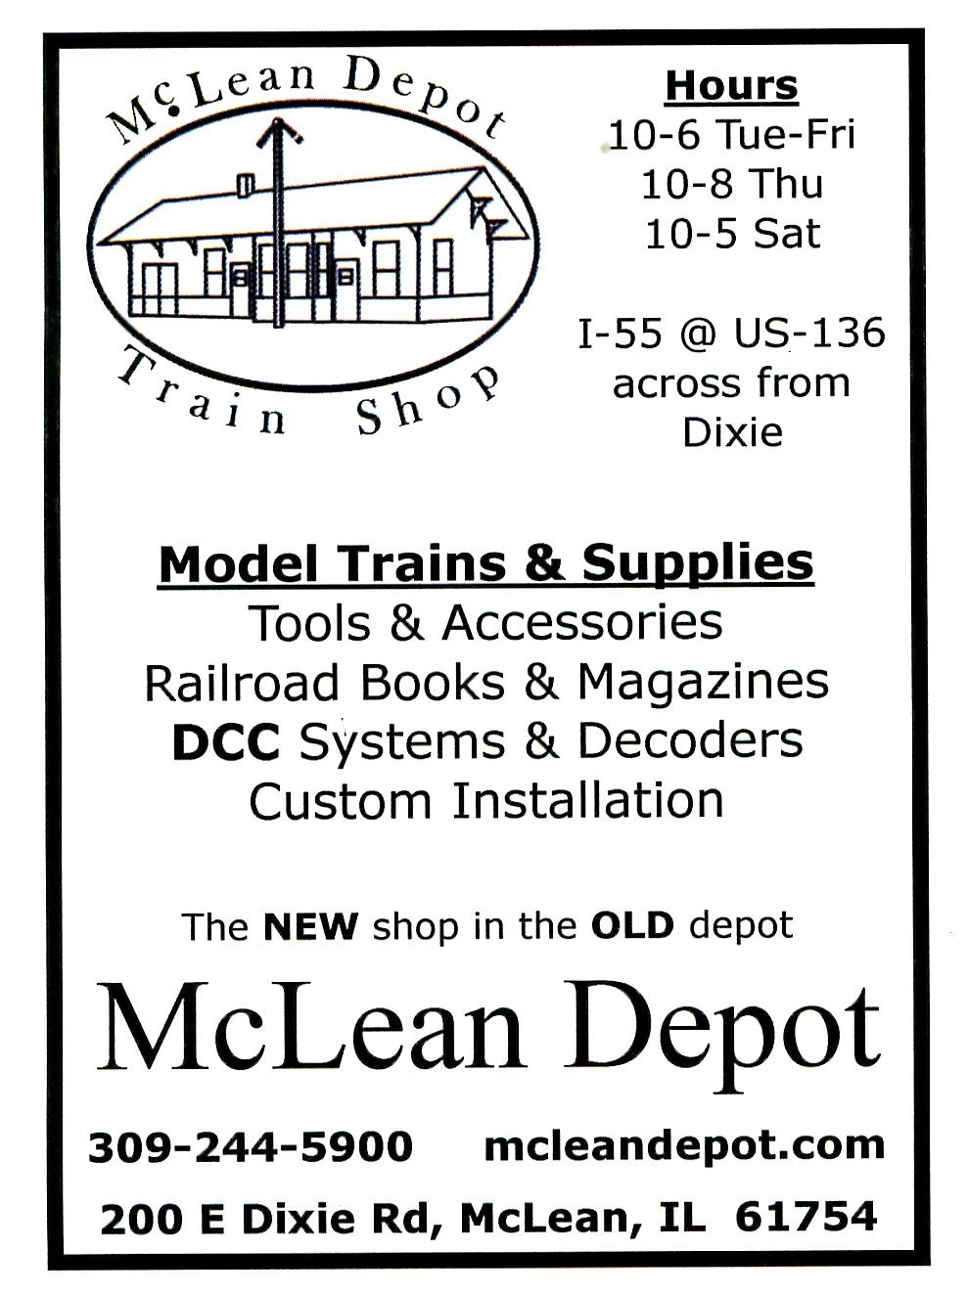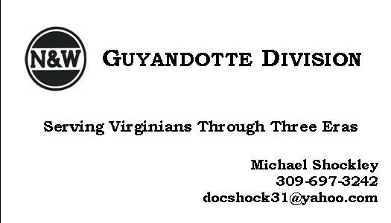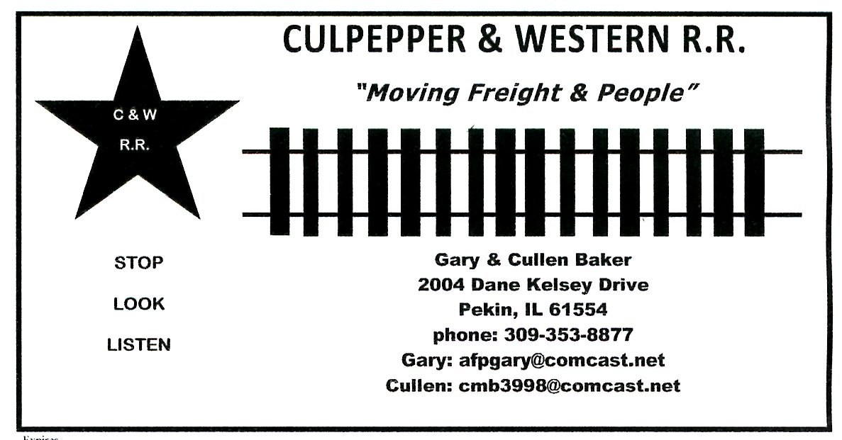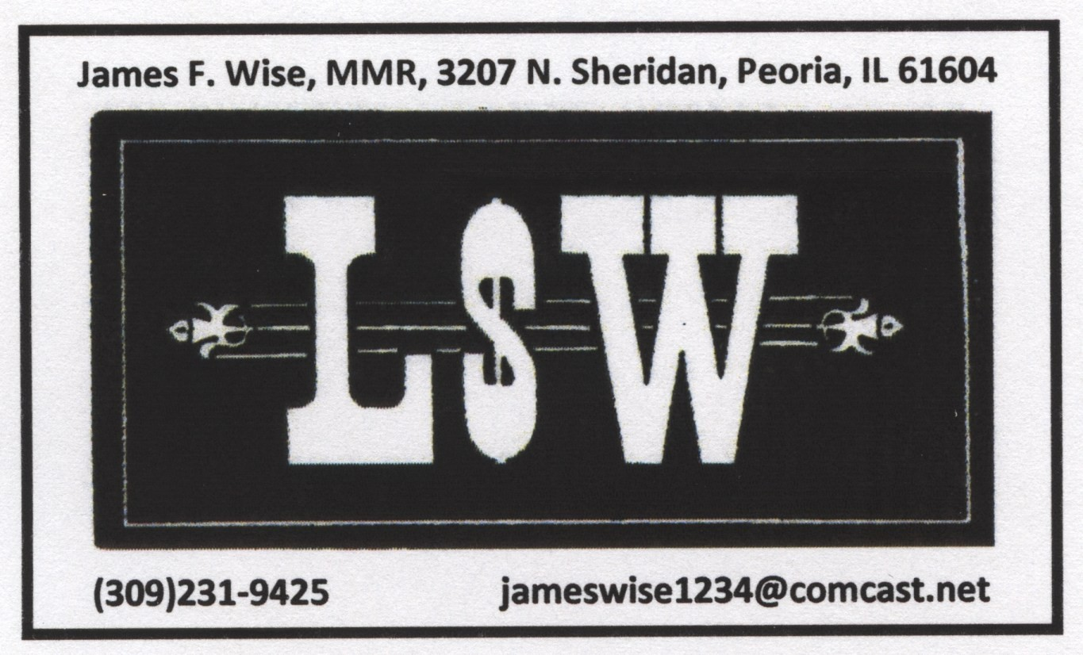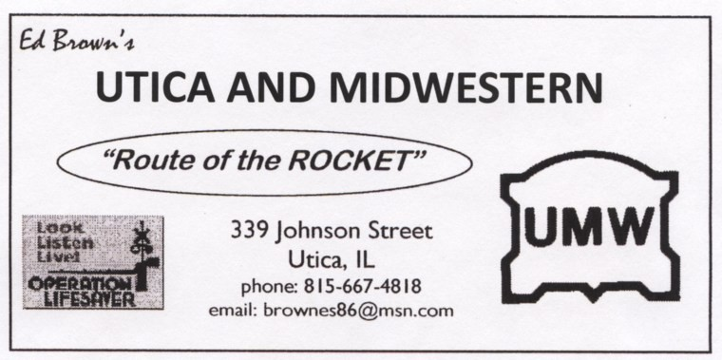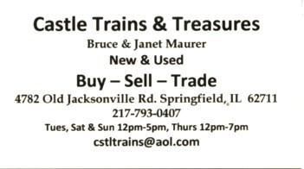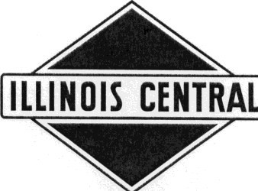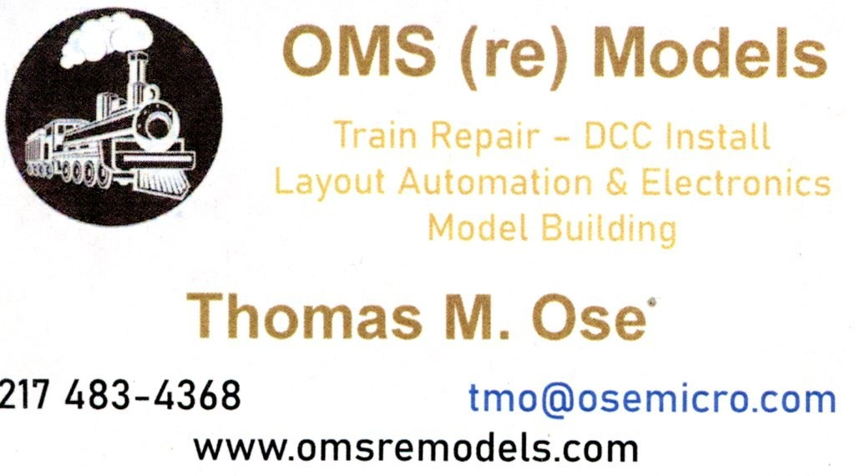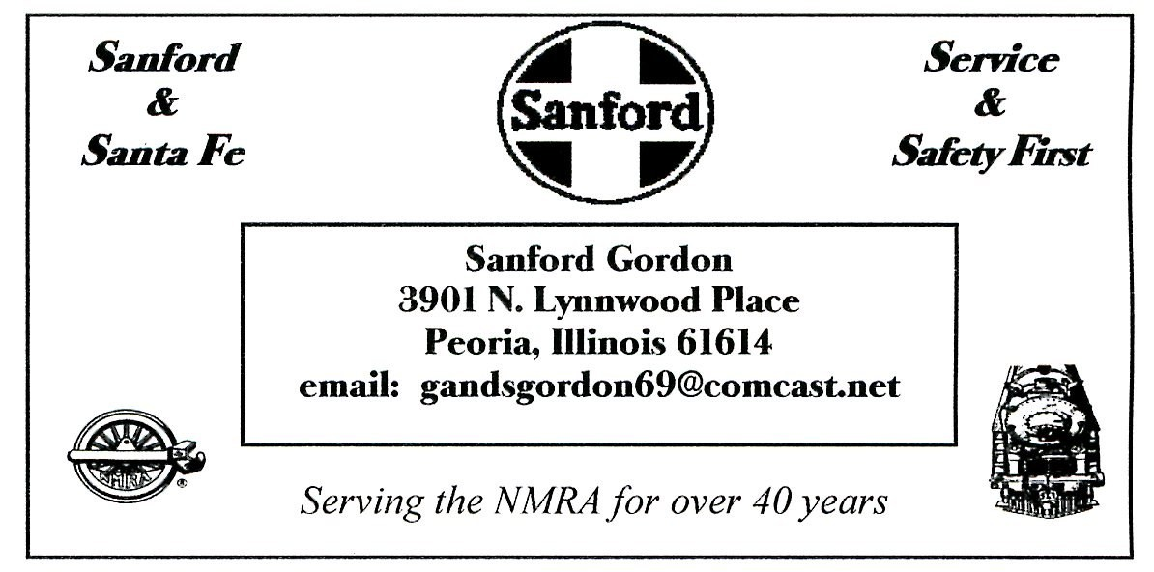

f

GREEN RIVER BRANCH

Kentucky Division

Illinois Central Railroad, 1957

Minton Dings, MMR®

15548
78
State Route

Havana, Illinois 62644

(309)241
-
4504

Affiliated with:

Illinois Valley Division, NMRA

National Model Railroad Association

Monticello Railroad Museum

GM&O Historical Association

RealRail, Bradenton, Florida

e
-
mail:
greenriverbranch1957@gmail.com

Serving the NMRA for over 50 years

itv
-
3
.com

IVD TIMETABLE  Minton Dings, MMR®  15548 State Route 78  Havana, Illinois 62644-6803 | FIRST CLASS MAIL

Postmaster:
Return Service Requested
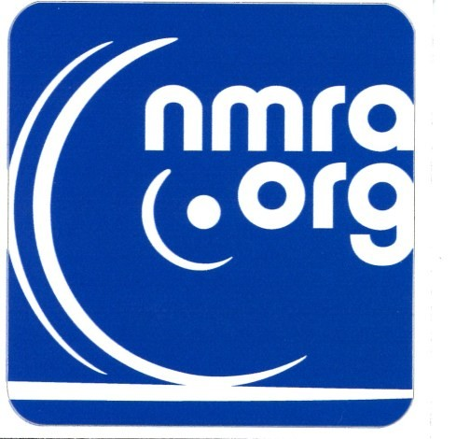
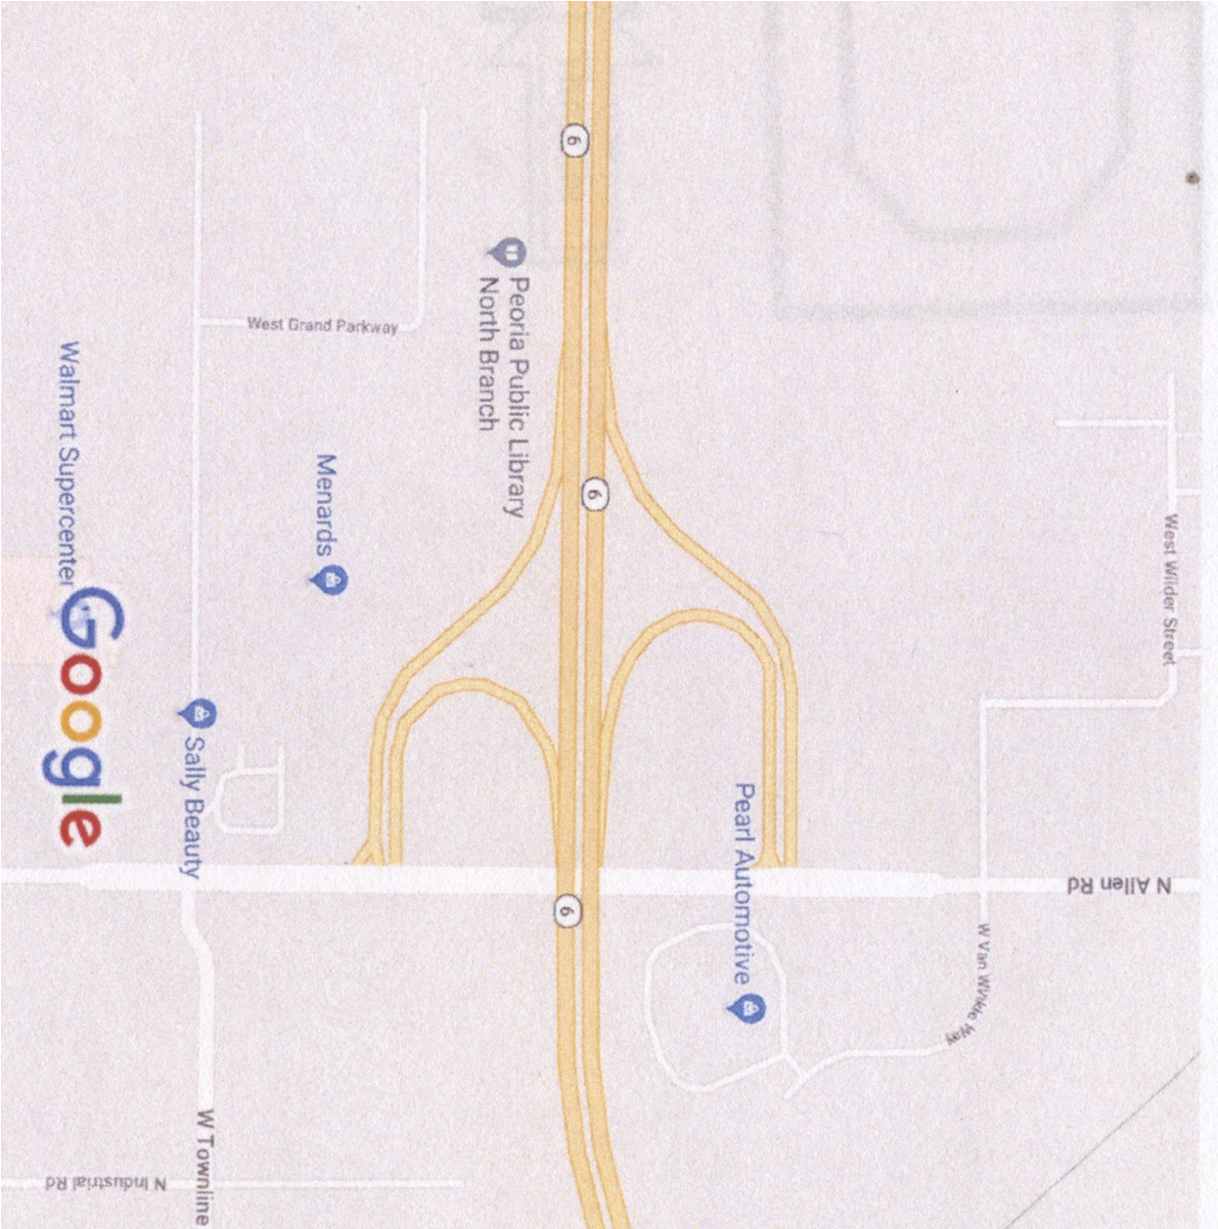

.

March 15, 2025

Illinois Valley Division of the NMRA

Division Meeting

Peoria Public Library, North Branch

Mckinley Room, (Inside the main door)

3001 West Grand Parkway, Peoria

Program and Clinic
“Make and Take”
:
ScratchbBuild a Billboard by Larry Nelson

Contests
(1) Diesel Locatives, and (2) Photos
of Models

